

|  |
| --- |
| JAVA PROJECT DOCUMENTATION |
| **MILK TEA SHOP** |
| **MILK TEA SHOP MANAGEMENT SYSTEM** |

|  |
| --- |
| Can Tho city, 10-15-2019 |

# PROJECT TEAM INTRODUCTION

* Project manager
  + Teacher. Luong The Anh
  + Email: [ltanh@ctu.edu.vn](mailto:ltanh@ctu.edu.vn)
* Team Leader/Analyst/Designer/Tester
  + Student. Dao Minh Trung Thuan
  + Student ID: Student1153187
  + Email: [DmtthuanA18088@cusc.ctu.edu.vn](mailto:DmtthuanA18088@cusc.ctu.edu.vn)
* Team Member/Developer/Tester
  + Student. Ha Thi Hong Tham
  + Student ID: Student1138919
  + Email: [HththamA18124@cusc.ctu.edu.vn](mailto:HththamA18124@cusc.ctu.edu.vn)
* Team Member/Developer/Tester
  + Student. Tan Tan Lap
  + Student ID: Student1146966
  + Email: [TtlapA18081@cusc.ctu.edu.vn](mailto:TtlapA18081@cusc.ctu.edu.vn)

# PROBLEM DEFINITION OF MILK TEA SHOP

Milk Tea Shop is a milk tea shop specializing in selling milk tea and fast food. The main customers that it serves are students. When customers come to the shop, they order food and choose their own seat that they like then pay for bill at cashier.

But recently, the number of customers is increasing. The shop manager feels difficult to record and manage not only the invoice but also revenue of the shop. In addition, employees cannot write lots of order bill every day. So, they want to have a system can help them to manage their shop that customers can order bill simpler and employees don’t work too much.

The system will provide functions:

* Customers can order food, choose their table that they like then pay at cashier
* Customers can register and log into system or enter discount code to receive the offer from shop
* Employees and manager must log in to use system.
* Employees can manage order bills in food tables, status of food tables, and food
* Manager can manage bills, employees, accounts and income of shop.
* Manager’s actions include view, insert, update, delete. But employee cannot delete or update anything. The order bill can be canceled when in the order process but not delete when customer has paid.

Beside that:

* The system must run smoothly, without errors from the system side.
* Fast execution speed, serving the crowded customer flow.

# CUSTOMER REQUIREMENT SPECIFICATION

## List of input to the system

**Account: User account in the system**

* Id: id account.
* Account: account name.
* Password: password.
* Roll: roll of account (1: customer, 2: employee, 3: manager).
* Name: name of account owner.
* Gender: gender of account owner.
* Birthday: the date of birth of account owner.
* Address: address of account owner.
* Phone: phone number of account owner.
* Email: email of account owner.
* Status: status of account (1: enable, 0: disable).

**Table Food: Information of table**

* Id: id table.
* X: coordinates X of table.
* Y: coordinates Y of table.
* Status: status of account (2: busy, 1: enable, 0: disable).

**Category: Category of food**

* Id: id category.
* Name: type name.
* Status: status of account (1: enable, 0: disable).

**Food: Information of food**

* Id: id food.
* Name: name of food.
* Id Category: classify on food (foreign key of Category).
* Price: price of food
* Status: status of account (1: enable, 0: disable).

**Discount: Information of discount**

* Id: id discount.
* Name: code value.
* Sale: discount values (example: 15%).
* Status: status of account (2: giving out, 1: enable, 0: disable).

**Bill: Information of bill**

* Id: id of bill.
* Id Table Food: id number of table (foreign key of Table Food).
* Id Customer: id number of Customer (foreign key of Account).
* Id Employee: id number of Employee (foreign key of Account).
* Id Discount: id number of Discount (foreign key of Discount).
* Sale: total sale of bill
* Check In: the time that customer paid bill.
* Check Out: the time that customer left the shop.

**Bill Detail: Information of bill detail**

* Id: id bill detail.
* Id Bill: id number of table Bill (Foreign Key of bill).
* Id Food: id number of table Food.
* Name Food: name ordered food.
* Id Category: id number category of food.
* Name Category: name category of ordered food.
* Quantity: quantity of food.
* Price: price of ordered food

## List of output expected from the system

**For Customer**

* Display food list.
* Display food category.
* Display bill details and total price when ordering.
* Display information of account when logged in.
* Display food table list when paid bill.

**For Employee**

* Display food table list.
* Display bill list of each table in that day
* Display bill details of each bill.
* Display bill details that customers are ordering.
* Display information of account when logged in.
* Display food list.
* Display food category.

**For Manager**

* Display table list.
* Display employee list and account of each employee.
* Display customer list and account of each customer.
* Display discount code list.
* Display bill list and bill details of each bill.
* Display food list.
* Display food category.
* Display income.
* Export income report.

## Overview of processes involved in the system

**For Customer**

* Watch category food and food list, choose food.
* Watch bill details that ordered.
* Customers can cancel order if they have not paid.
* Pay bill and watch table list, choose table.
* Login account to discount bill.
* Enter discount code.
* Watch information of account.
* Register account.

**For Employees**

* Watch category food and food list.
* Watch bill details that customer is ordering.
* Watch table list.
* Watch bill list and bill details of each table in that day.
* Watch information of account.
* Check out the bill of table.

**For Manager**

* Manage category food: watch, insert, update, delete categories food.
* Manage food: watch, insert, update, delete food.
* Manage bill: watch bills and bill details.
* Manage employee: watch, insert, update, delete information and account of employees.
* Manage customer: watch, insert, update, delete information and account of customers.
* Manage discount code: watch, insert, update, delete discount code.
* Manage income of shop, export report.

## Hardware and software required for implementing the project

### Hardware

|  |  |
| --- | --- |
| CPU | 1.8 GHz or faster processor. Quad-core or better recommended. |
| Ram | 2 GB of RAM. 8 GB of RAM recommended. |
| Hard disk space | Minimum of 800MB up to 256 GB or more of available space depending on increasing database. |
| Hard disk speed | To improve performance, install Operating System and Project run on SSD drive. |
| Display screen size | Supports a minimum display 1600 x 900 |

### Supported locale:

* Language: English
* Currency unit: Dollars ($)

### Environment

|  |  |
| --- | --- |
| Operating system | Project will install and run on the following operating systems (Windows 10 64 bit recommended) |
| Environment | Java 11.0.4  JavaFX 2.0 |
| Database server | Microsoft SQL Server (SQL Server 2016 recommended)  Microsoft SQL Server Management Studio 18 for managing database |

# CUSTOMER ACCEPTANCE CRITERIA

**For Customer**

* Customers can watch food and price in food list.
* Customers can order food and pay bill.
* Customers can cancel ordering when they had not pay.
* Customers can choose table food after paying bill.
* Customers can login or enter discount code in order to discount bill.
* Customers can register, account will create automatically with information that customer registered.
* Customers can watch information of their account.

**For Employee**

* Employees must login to use system.
* Employees can watch bill and table that customer is ordering.
* Employees can watch list of food.
* Employees can watch status of tables and bills in that day of each table.
* Employees can watch information of their account.

**For Manager**

* Managers can watch, insert, update, delete all accounts.
* Managers can watch, edit their account.
* Managers can watch, insert, update, delete information of food.
* Managers can watch, insert, update, delete food table.
* Managers can watch, insert, update, delete discount code.
* Managers can watch bill details.
* Managers can watch income of shop and export file report.

# PROJECT PLAN

## Project details

### Name Project

**Milk Tea Shop** - Milk Tea Shop Management System

### Date of Project Plan:

* Starting: 15-10-2019
* Ending: 26-11-2019

### Project Vision/Objectives

Develop a management system application which stores information of bills, categories food, foods, tables food, employees, customers and manages them, also has enough necessary functions for the shop's owner to work effectively, such as statistic bill, calculate revenue, export report. This application supports customer can order food, pay bill and choose table at cashier easily. It helps employees can manage tables and bills of each table in that day effectively.

### Scope

Basic manage milk tea shop, statistic bill, calculate revenue, export report bill, order food, pay bill.

### Our understanding about the Client organization

Milk Tea Shop is a milk tea shop specializing in selling milk tea and fast food. The main customers that it serves is students. When customers come to the shop, they order food and pay bill. The shop's owner need application which supports managing bill, calculate revenue, export report.

### Project with Organization with Responsibilities and Authorities

* Dao Minh Trung Thuan – Leader: System, database analysis and design, design, coding, testing.
* Ha Thi Hong Tham – Member: design, coding, testing.
* Tan Tan Lap – Member: design, coding.

## Project initiation/Requirement Documents

* Java SE JDK 11: <https://docs.oracle.com/en/java/javase/11/>
* IntelliJ IDEA: <https://www.jetbrains.com/idea/documentation/>
* JavaFX 2: <https://docs.oracle.com/javafx/2/>
* JMetro: <https://www.pixelduke.com/java-javafx-theme-jmetro/>
* SQL Server: <https://docs.microsoft.com/en-us/sql/sql-server/sql-server-technical-documentation?view=sql-server-ver15>
* JDBC Driver for SQL Server: <https://docs.microsoft.com/en-us/sql/connect/jdbc/microsoft-jdbc-driver-for-sql-server?view=sql-server-ver15>
* IText Java: <https://www.tutorialspoint.com/itext/index.htm>
* BCrypt: <https://docs.spring.io/spring-security/site/docs/current/api/org/springframework/security/crypto/bcrypt/BCrypt.html>

## Deliverable

* Application.
* User guide.
* Project document.

## Project dependencies

* Lacking of time.
* Illness or family busy.
* Members slow process or out of the project.

## Major project prototype

Milk Tea Shop - Milk Tea Shop Management System

## Quality plan

* **Review activities:** At least 3 times a week, each meeting there is a check for each member in group to review processing, help to solve hard trouble.
* **Testing activities:** Ask for some help from a real shop and test the project with their customers, employees and shop’s owner.
* **Backup and recovery strategies:** One copy is stored in Github and ach member store one copy in their own computer.

# GUI STANDARDS DOCUMENTATION

## Project documentation

* **Document theme and Color scheme:** Slide - Basic (Elegant)
* **Background color:** White
* **Font size:** 13
* **Font color:** Black
* **Font style:** Time New Roman
* **Text alignment:** Justify
* **Heading 1:** font size 18, font style bold, capitalize letter
* **Heading 2:** font size 16, font style bold
* **Heading 3:** font size 14, font style bold

## User interface

Use CSS Stylesheet for design with main theme is JMetro

**Root**

* Font family: "Segoe UI Semibold"
* Font size: 16
* Text fill: #181818

**Pane, Border Pane, Anchor Pane, V-Box, H-Box, Grid Pane, Scroll Pane, Flow Pane**

* Padding: 5
* Spacing: 10
* Alignment: center
* H-gap: 10
* V-gap: 10

**Button**

* Text fill: #F2F8FD
* Background color: #0078D7
* Border color: #0078D7
* Text alignment: center
* Row v-alignment: middle
* Border style: solid
* Border width: 1
* Padding: top-bottom: 5, left-right: 20
* Content display: top
* Alignment: center
* Effect: drop shadow with “three-pass-box, #00233F, 15, 0, 5, 5”

**Field, Date Picker, Radio Button, Combo Box**

* Font-family: "Segoe UI"
* Width: 300

**Table Column, Table View**

* Font size: 13

**Wrapper**

* Background image: use image with link "/asset/brand/Background.png"
* Background repeat: no-repeat
* Background size: cover
* Background position: center

**Container**

* Background color: #F2F8FDDD
* Border color: #00508F
* Padding: 15

**Title**

* Font size: 24
* Text fill: #00508F

# INTERFACE DESIGN DOCUMENT

Using FXML for design view form of application

## Customer

### Form watch information account

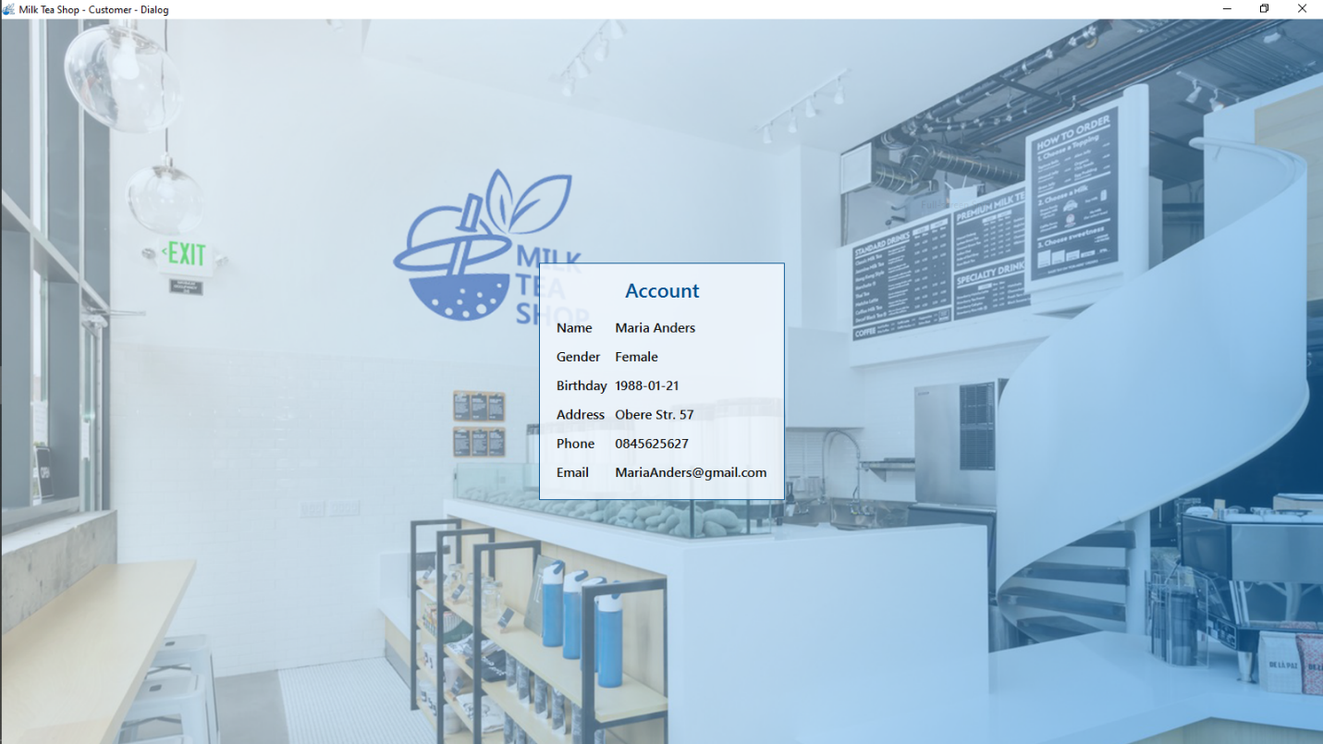

Figure : Watch information account

|  |  |
| --- | --- |
| **Name control** | **Description** |
| Name label | Display name |
| Gender label | Display gender |
| Birthday label | Display birthday |
| Address label | Display address |
| Phone label | Display phone |
| Email label | Display email |

### Form change password

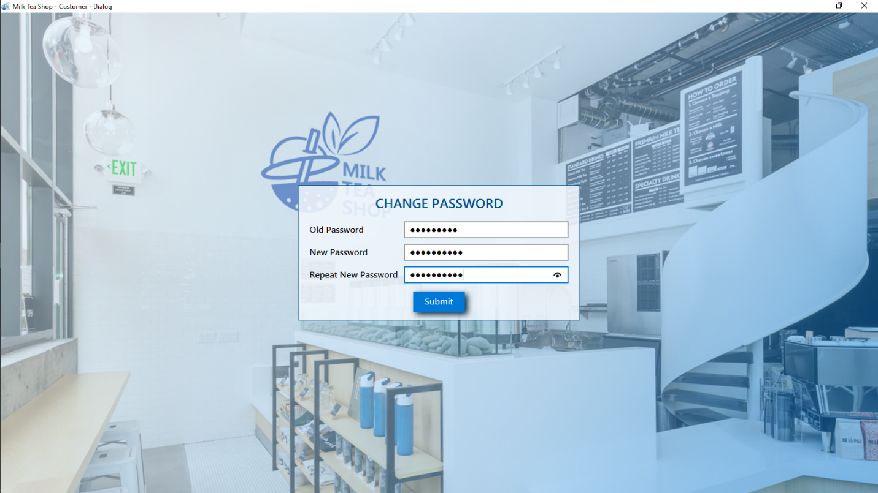

Figure : Form change password

|  |  |
| --- | --- |
| **Name control** | **Description** |
| Old password field | Enter old password |
| New password field | Enter new password |
| Repeat password field | Re-enter new password |
| Submit button | Submit for changing password |

### Form choose table

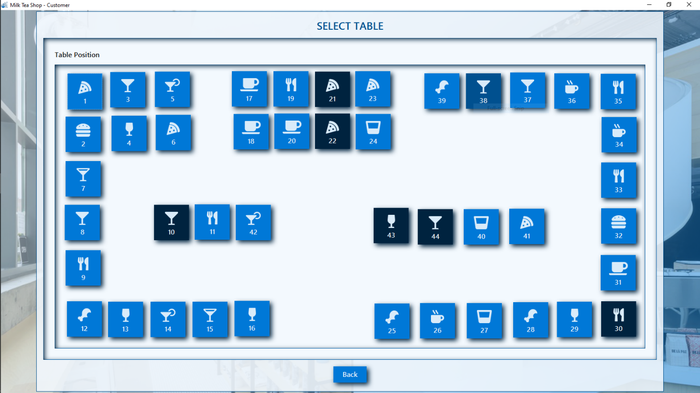

Figure : Form choose table

|  |  |
| --- | --- |
| **Name control** | **Description** |
| Table buttons | Choose table to pay bill |
| Back button | Back to form order food |

### Form enter discount code

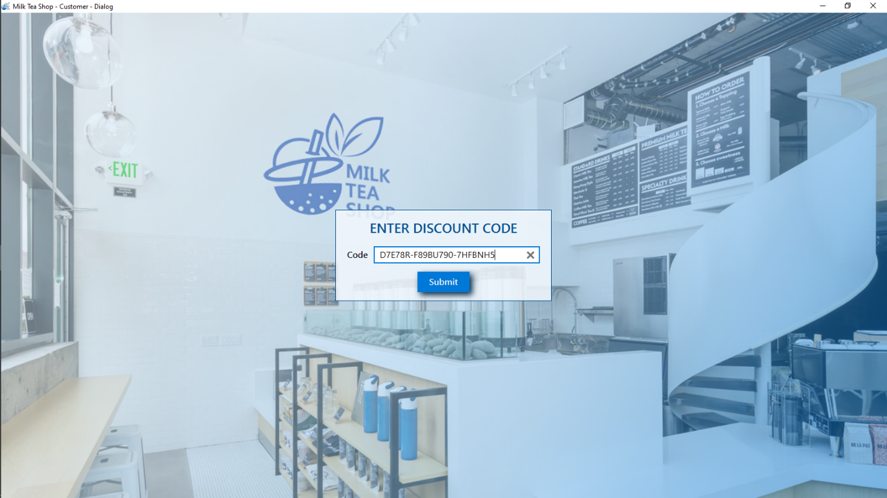

Figure : Form enter discount code

|  |  |
| --- | --- |
| **Name control** | **Description** |
| Discount code text field | Enter discount code |
| Submit button | Submit for entering discount code |

### Form login

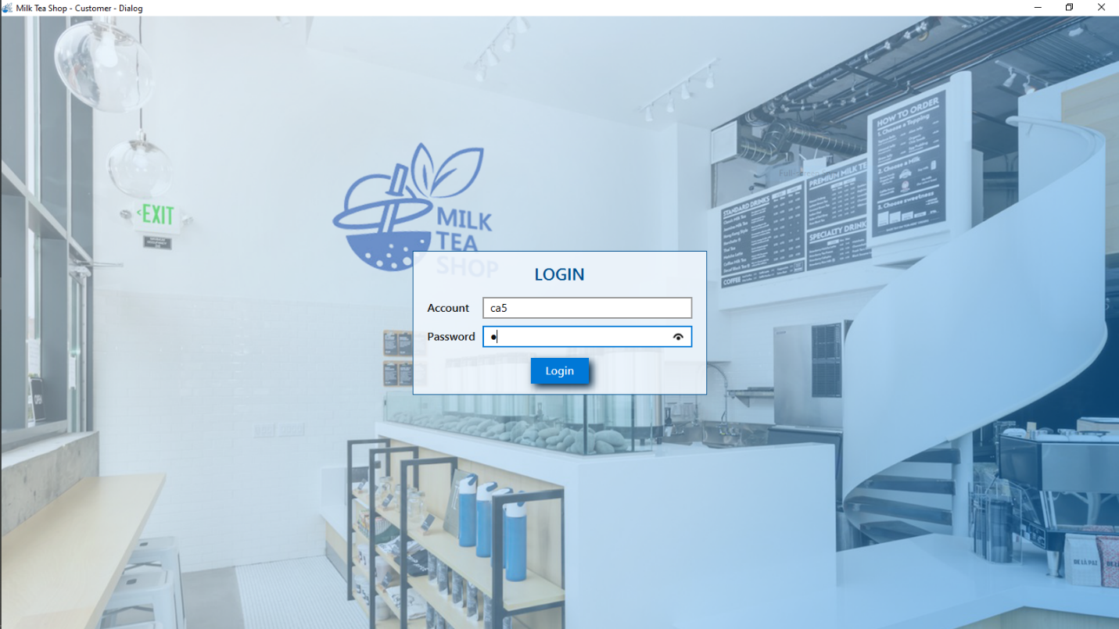

Figure : Form login for customer

|  |  |
| --- | --- |
| **Name control** | **Description** |
| Account text field | Enter name account |
| Password field | Enter password |
| Login button | Login system by customer account |

### Form order food

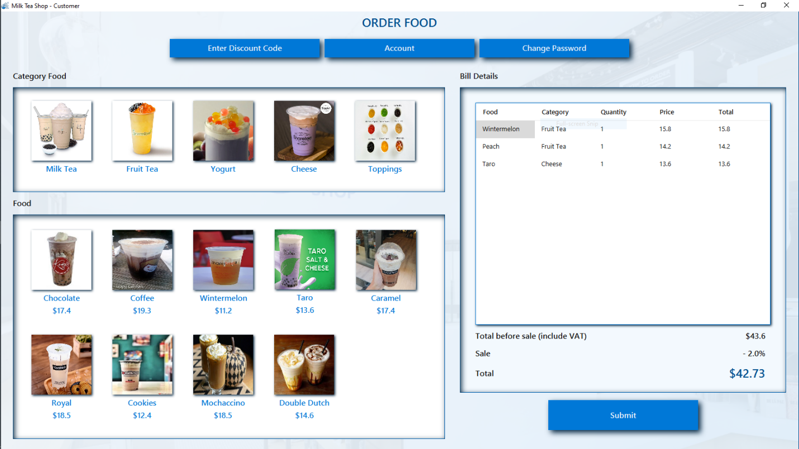

Figure : Form order food

|  |  |
| --- | --- |
| **Name control** | **Description** |
| Enter discount code button | Call form enter discount code |
| Account button | Call form watch information account |
| Change password button | Enter password |
| Login button | Login system by customer account |

### Form pay bill

### Form register

### Form welcome customer

# TABLE DESIGN DOCUMENTATION

|  |  |  |  |  |  |
| --- | --- | --- | --- | --- | --- |
| **Name of the Table** | **Table Description** | **Number of Fields** | **Primary Key** | **Related Tables** | **Foreign Key** |
| Account | User account in the system. | 11 | id |  |  |
| Table | Information of table. | 4 | id |  |  |
| Category | Category of food. | 3 | id |  |  |
| Food | Information of food. | 5 | id | 1. Category | idCategory |
| Discount | Information of discount. | 4 | id |  |  |
| Bill | Information of bill. | 8 | id | 1. Table  2. Account  3. Discount | idTable  idCustomer  idEmployee  idDiscount |
| BillDetail | Information of bill detail. | 8 | id | Bill | idBill |